Competitive Landscape Breakdown
To position SendCleared effectively, it helps to group the market into four main categories. Each approaches email checking and client approvals differently:
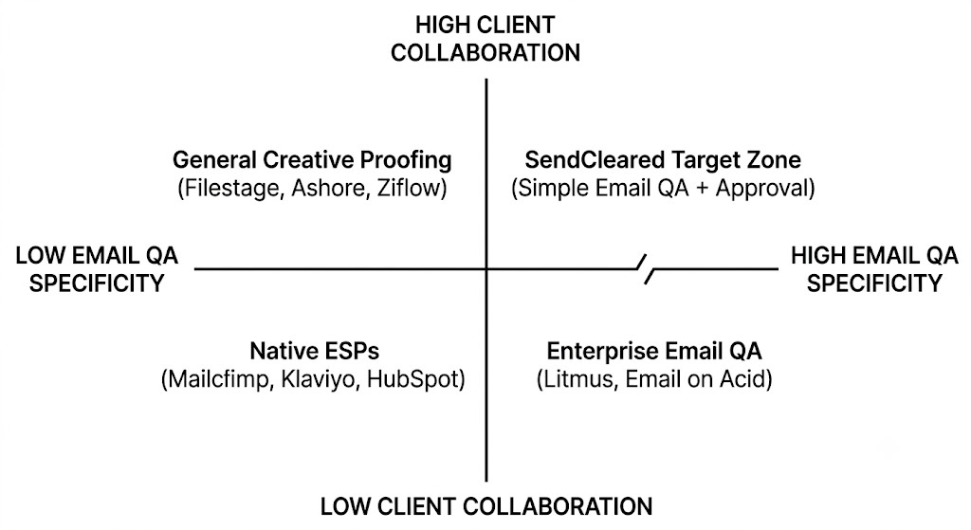

1. Enterprise Email QA Platforms
- Key Players: Litmus (including Litmus Proof), Email on Acid (Validity).
- Strengths: 100+ inbox rendering previews (Outlook, Gmail, Apple Mail), dark mode checks, spam score analysis, accessibility testing.
- Weaknesses: Expensive ($100–$500+/mo), overkill for small agencies/freelancers, clunky external client sharing workflows.
- SendCleared Opportunity: Litmus is built for in-house enterprise teams. Agencies and freelancers don't want to pay $200/mo just to show a client an email preview.

2. Specialized Email QA & Developer Tools
- Key Players: Parcel.io, Mailtrap, MailerCheck, EmailSprouts.
- Strengths: Code-level checking, link validation, merge tag parsing, sandboxed testing for developers.
- Weaknesses: Built for email developers/coders, not client-facing account managers. Lacks frictionless client sign-off tools.
- SendCleared Opportunity: Bridges the gap between technical checking and client presentation.

3. General Creative Proofing & Client Approval Tools
- Key Players: Ashore, Filestage, Ziflow, Blink Approval.
- Strengths: Excellent client sign-off portals, inline commenting, version tracking.
- Weaknesses: Designed for PDFs, videos, and static images. They don't understand email mechanics—they won't check if a *|FNAME|* merge tag is broken, if a UTM tag is missing, or if an unsubscribe link works.
- SendCleared Opportunity: General proofing tools don't parse dynamic email code or check links automatically.

4. Native ESPs (Email Service Providers)
- Key Players: Mailchimp, Klaviyo, ActiveCampaign, HubSpot.
- Strengths: Built-in test email features, basic inbox previewers.
- Weaknesses: Granting clients access to the ESP is a security nightmare. Sending a standard "Test Email" to a client often breaks merge tags, lands in their spam folder, or leads to vague feedback in long email chains.
- SendCleared Opportunity: Acts as a safe buffer between the agency’s ESP draft and the client's inbox.

Positioning Evaluation: Option A vs. Option B
Dimension | Option A: "Stop sending emails with mistakes" | Option B: "Get client sign-off in one click"
Primary Hook | Fear & Risk (Mistakes, broken links) | Efficiency & Professionalism (Speed, fewer threads)
Target Buyer Pain | "I'm terrified of hitting send and embarrassing myself." | "I waste hours chasing client approvals across 12 email threads."
Perceived Value | Feature / QA Tool (Low willingness to pay) | Outcome / Workflow Solution (Higher willingness to pay)
Differentiator | Competes directly with cheap QA extensions & checklists. | Differentiates from generic proofing tools by being email-native.

